NAMA : M.AL FAIZ PUTRA JALASENANDRA

NIM : 21091397072

Praktikum 2

1. #include <iostream>

using namespace std;

int main()

{

int matA[2][2] = {4, 2, 8, 10};

int matB[2][2] = {-5, 8, 4, -12};

int j,k;

cout << "Matriks A" << endl;

for (int i=0; i<2; i++){

for (int j=0; j<2; j++){

cout << matA[i][j] << " ";

}

cout << endl;

}

cout << "Matriks B" << endl;

for (int i=0; i<2; i++){

for (int j=0; j<2; j++){

cout << matB[i][j] << " ";

}

cout << endl;

}

cout << endl;

cout << "Hasil penjumlahan matriks A dan B " << endl;

for (int i=0; i<2; i++){

for (int j=0; j<2; j++){

cout << matA[i][j] + matB[i][j] << " ";

}

cout << endl;

}

system("PAUSE");

return 0;

}

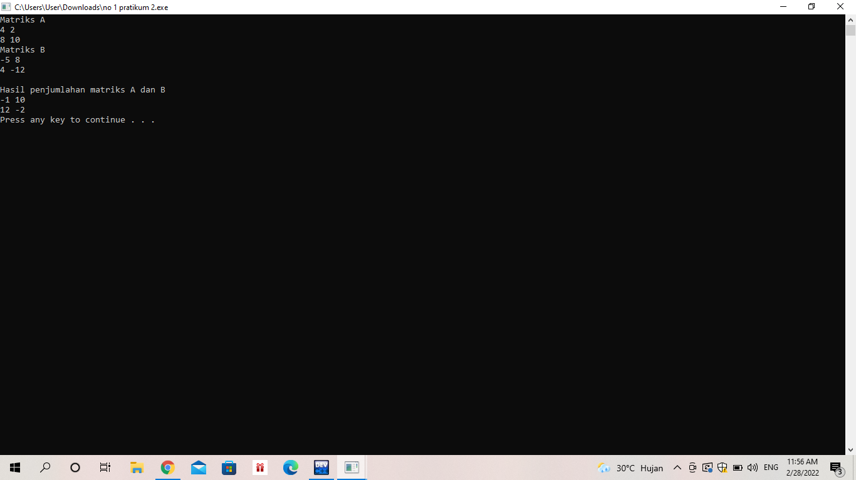

2. #include <iostream>

using namespace std;

int main()

{

int matA[2][2] = {4, 2, 8, 10};

int matB[2][2] = {-5, 8, 4, -12};

int j,k;

cout << "Matriks A" << endl;

for (int i=0; i<2; i++){

for (int j=0; j<2; j++){

cout << matA[i][j] << " ";

}

cout << endl;

}

cout << "Matriks B" << endl;

for (int i=0; i<2; i++){

for (int j=0; j<2; j++){

cout << matB[i][j] << " ";

}

cout << endl;

}

cout << endl;

cout << "Hasil pengurangan matriks A dan B " << endl;

for (int i=0; i<2; i++){

for (int j=0; j<2; j++){

cout << matA[i][j] - matB[i][j] << " ";

}

cout << endl;

}

system("PAUSE");

return 0;

}

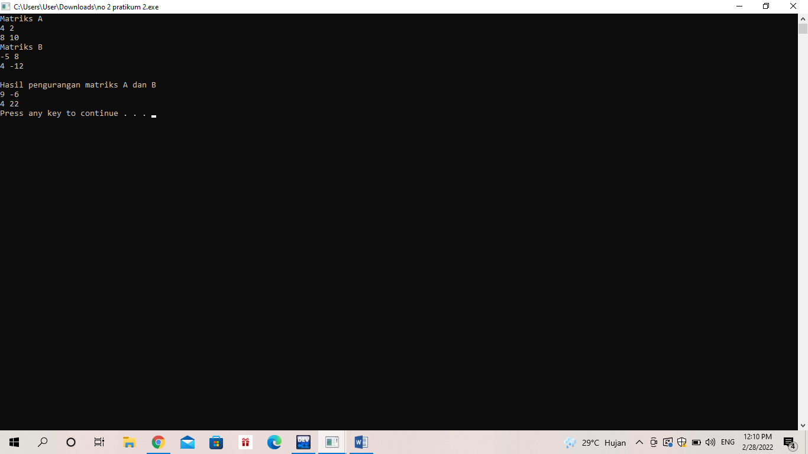

3. #include <iostream>

using namespace std;

int main()

{

int matA[2][2] = {4, 2, 8, 10};

int matB[2][2] = {-5, 8, 4, -12};

int j,k;

cout << "Matriks A" << endl;

for (int i=0; i<2; i++){

for (int j=0; j<2; j++){

cout << matA[i][j] << " ";

}

cout << endl;

}

cout << "Matriks B" << endl;

for (int i=0; i<2; i++){

for (int j=0; j<2; j++){

cout << matB[i][j] << " ";

}

cout << endl;

}

cout << endl;

cout << "Hasil perkalian matriks A dan eksponen 5 " << endl;

for (int i=0; i<2; i++){

for (int j=0; j<2; j++){

cout << matA[i][j] \* 5 << " ";

}

cout << endl;

}

system("PAUSE");

return 0;

}

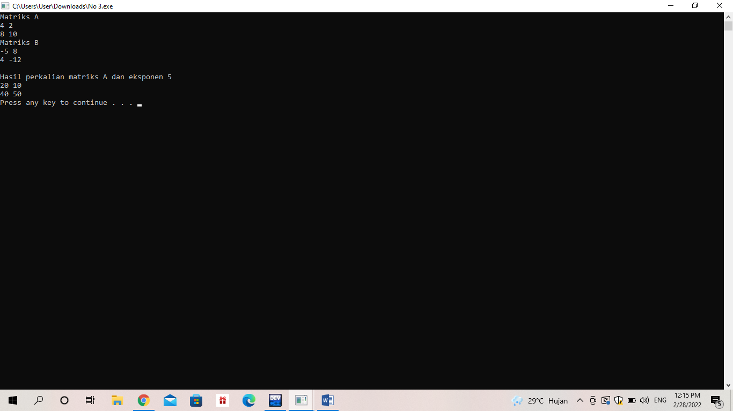

4. #include <iostream>

using namespace std;

void cetakMatrixA(int mA[2][2]){

for(int i=0; i<2; i++){

for(int j=0; j<2;j++){

cout<<mA[i][j]<<"";

}

cout<<endl;

}

}

void cetakMatrixB(int mB[2][2]){

for(int i=0; i<2 ;i++){

for(int j=0; j<2; j++){

cout<<mB[i][j]<<"";

}

cout<<endl;

}

}

void perkalian(int mA[2][2], int mB[2][2], int mHasil[2][2]){

int jmlh = 0;

for (int i = 0; i < 2; i++){

for (int j = 0; j < 2; j++){

for (int k = 0; k < 2; k++){

jmlh = jmlh + (mA[i][k] \* mB[k][j]);

}

mHasil[i][j]=jmlh;

jmlh =0;

}

}

}

void cetakPerkalian(int mHasil[2][2]){

for (int i = 0; i < 2; i++){

for (int j = 0; j < 2; j++){

cout << mHasil[i][j] <<"";

}

cout<<endl;

}

}

int main(){

int matrixA[2][2];

int matrixB[2][2];

int matrixHasil[2][2];

matrixA[0][0] = 4;

matrixA[0][1] = 8;

matrixA[1][0] = 2;

matrixA[1][1] = 10;

matrixB[0][0] = -5;

matrixB[0][1] = 4;

matrixB[1][0] = 8;

matrixB[1][1] = -12;

cout <<"Matriks A : "<< endl;

cetakMatrixA(matrixA);

cout << endl;

cout <<"Matriks B : "<< endl;

cetakMatrixB(matrixB);

cout << endl;

cout <<"Hasil Perkalian Matriks A & B : "<< endl;

perkalian(matrixA, matrixB, matrixHasil);

cetakPerkalian(matrixHasil);

return 0;

}

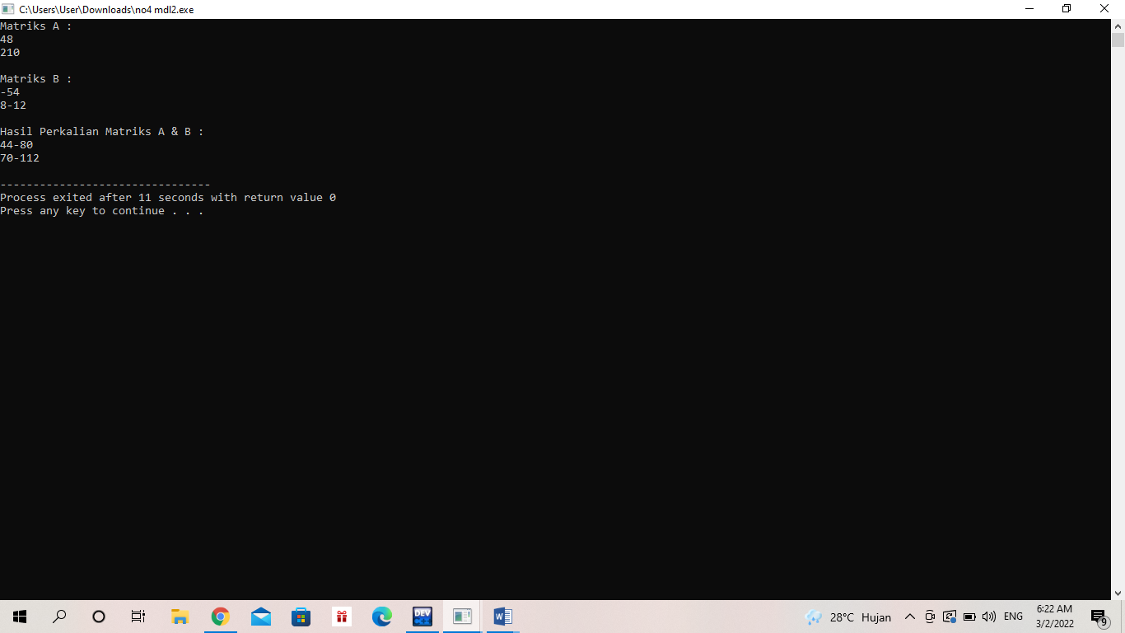

5. #include <iostream>

using namespace std;

int main()

{

int matA [2][2]={1,2,3,4};

cout<<"Matriks A"<<endl;

for (int i=0;i<2;i++){

for(int j=0;j<2;j++){

cout<<matA[i][j]<<" ";

}

cout<<endl;

}

cout<<endl;

cout<<"Transpose Matriks A \n";

for (int i=0;i<2;i++){

for (int j=0;j<2;j++){

cout<<matA[j][i]<<" ";

}

cout<<endl;

}

return 0;

}

